LARRY HUSHOUR
Mayor

TIM J. WASHABAUGH
Council President
Council Members
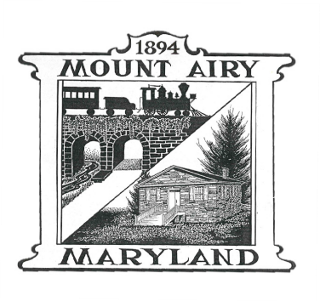
LYNNE P. GALLETTI Secretary

KARL L. MUNDER
JASON P. EVANS
STEPHEN L. DOMOTOR

Town Council and Planning Commission
2023 Master Plan
Joint Work Session Agenda
November 20, 2024
6:30 p.m. to 9:30 p.m.

This Joint Work Session is being held at Town Hall
Located at 110 S. Main Street, Mount Airy, Maryland 21771

This is a joint work session between the Town Council and the Planning Commission on the Draft 2023 Master Plan. The public is encouraged to come to this Joint Work Session to listen to this open discussion; public comments will be heard at this open work session.

The doors will open at 6:00 p.m. so the public can view the proposed 2023 Mount Airy - Master Plan.

- 6:30 p.m. – 6:40 p.m. ~ Introduction by Mayor Hushour & Council President
Washabaugh

- 6:40 p.m. – 6:45 p.m. ~ Planning Commission Chair High-level overview of the plan.

- 6:45 p.m. – 8:15 p.m. ~ Open discussion about the plan, Town Council and Planning
Commission.

- 8:15 p.m. – 9:00 p.m. ~ Open discussion about the Mission statement and Goals and
Objectives

- 9:00 p.m. – 9:25 p.m. ~ Citizen comments and concerns if needed

- 9:25 p.m. – 9:30 p.m. ~ Council President Closing or wrap up and next steps.

Citizens are urged to submit comments or concerns in writing to jbreeding@mountairymd.gov. These will be shared with both the Town Council and the Planning Commission.

This Joint Work Session will be broadcast via Carroll Media Center and posted on the Town's Facebook Page.

FOR INFORMATION ON TDD/TTY, PLEASE CALL THE MARYLAND RELAY SERVICES at (800) 735-2258

