LARRY HUSHOUR
Mayor

TIM J. WASHABAUGH
Council President
Council Members
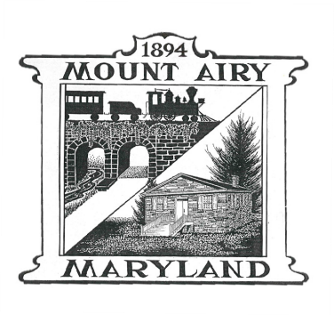
JASON P. EVANS Secretary

KARL L. MUNDER
SEAN M. KELLY
STEPHEN L. DOMOTOR

SANITATION AND RECYCLING COMMISSION AGENDA
WEDNESDAY 09/17/2025; 7:00 p.m.

Call to Order

Pledge of Allegiance

Approval of Minutes (July 2025 minutes)

Citizens Comments

J and J Comments/Concerns

Old Business
Recycling Flyers from Frederick County to distribute at Town events; Farmer’s
Market
35 Gallon Toters Update - Wildwood HOA Meeting
Electronic Recycling Event Update – Advertising – electronic signs
Frederick County Charge for Yard Waste – Impact Budget?

New Business
Green Fair At Farmer’s Market – Sept 24; 3 to 7
Hand out Electronic and Recycling Flyers?
If so, need to reserve space with Town
Fall National Drug Take Back Day – October 25, 2025
Is MAPD participating this year; if so, do they want the signs?

Council Liaison Report

Adjourn

