LARRY HUSHOUR
Mayor

TIM J. WASHABAUGH
Council President
Council Members
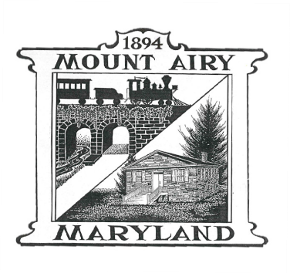
JASON P. EVANS Secretary

KARL L. MUNDER
SEAN M. KELLY
STEPHEN L. DOMOTOR

SANITATION AND RECYCLING COMMISSION AGENDA
WEDNESDAY 07/16/2025; 7:00 p.m.

Call to Order

Pledge of Allegiance

Welcome New Member Linda Shaff

Approval of Minutes (May 2025 minutes)

Citizens Comments

J and J Comments/Concerns

Old Business
Recycling Flyers from Frederick County to distribute at Town events; Farmer’s
Market

Carroll County town residents having access to Frederick County landfill

Downtown Recycling Center Monitoring

35 Gallon Toters Update

Electronic Recycling Event Update

New Business
Frederick County New Charge for Yard Waste

Council Liaison Report

Adjourn

