LARRY HUSHOUR
Mayor

TIM WASHABAUGH, Council President
LYNNE GALLETTI, Secretary
KARL MUNDER
STEPHEN DOMOTOR
JASON EVANS

Flat Iron Task Force
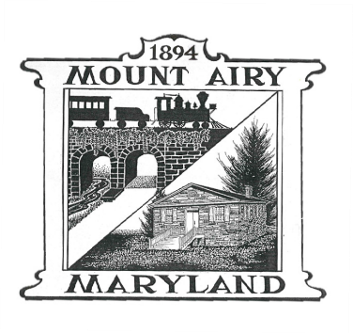
LARRY VALETT, Chair
MIKE EACHO, Vice Chair
DIANN LINTON, Treasurer
ADELE CONNOLLY, Secretary
LYNNE GALLETTI, Liaison

Commission Members:
CHARLES BECK
RICK DYE
LEE HAIGWOOD
NIKKI JEFFRIES
OLIVIA KUEHNER
JIM MOLESWORTH

FLAT IRON TASK FORCE
Meeting Agenda
Tuesday, May 28, 2024
7:00 p.m.

- Call to Order and Pledge

- Approval of Prior Meeting Minutes - Secretary

- Mayor Update

- Council Liaison Update

- Chairman Update

- Subcommittee Updates

- Public Discussion

- Next Meeting

- Adjournment

