LARRY HUSHOUR
Mayor

TIM J. WASHABAUGH
Council President
Council Members
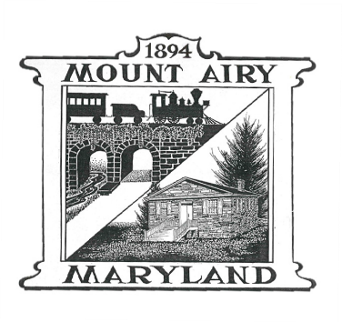
LYNNE P. GALLETTI Secretary

KARL L. MUNDER
JASON P. EVANS
STEPHEN L. DOMOTOR

SANITATION AND RECYCLING COMMISSION AGENDA
WEDNESDAY 05/21/2025; 7:00 p.m.

Call to Order

Pledge of Allegiance

New Member – Diane Lowe

Approval of Minutes (March 2025 minutes)

Citizens Comments

J and J Comments/Concerns

Commission Elections (Chair, Co-Chair, and Secretary)

Old Business
Shred & Battery Event: April 19, 2025 – Report 9,350 pounds collected

Curbside Bulk Pick up - May 10, 2025- Report/Problems?

Recycling Flyers from Frederick County to distribute at Town events; Farmer’s
Market

Yard Waste Dates to be added for new contract year (starting July 2025)

New Business
Discuss purchasing 35 Gallon Toters for Wildwood Senior Housing

Council Liaison Report

Adjourn

