LARRY HUSHOUR
Mayor

TIM J. WASHABAUGH
Council President
Council Members
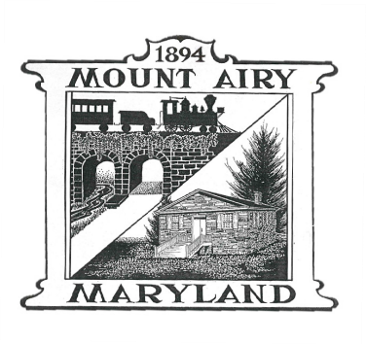
LYNNE P. GALLETTI Secretary

KARL L. MUNDER
JASON P. EVANS
STEPHEN L. DOMOTOR

SANITATION AND RECYCLING COMMISSION AGENDA
WEDNESDAY 03/19/2025; 7:00 p.m.

Call to Order

Pledge of Allegiance

Approval of Minutes (January 2025 minutes)

Citizens Comments

J and J Comments/Concerns

Old Business
Shred & Battery Event: April 19, 2025
Signs Need to placed April 13 (Does Mary/Nicole have signs? – (Peggy can put out signs)
Traffic Cones – Mike needs to get from Town

Curbside Bulk Pickup – Curbside Pickup - May 10, 2025
Update list of items to give to Gina

New Business
Yard Waste Dates – to be updated when contract approved
Recycling Flyers from Frederick County to distribute at Town events; Farmer’s
Market
Budget?

Council Liaison Report

Adjourn

